Ideation Phase
Brainstorm & Idea Prioritization Template

Date | 06 December 2025
Project Name | SkyWings - Flight Booking Application
Maximum Marks | 4 Marks

Brainstorm & Idea Prioritization Template:h
The brainstorming phase helped identify and explore ideas to build a smart and user-friendly flight booking application. The goal was to generate creative and practical ideas that enhance the booking experience for passengers while providing flight management tools for administrators.
This brainstorming session encouraged open-ended thinking where ideas were freely shared without judgment. Concepts were clustered and prioritized based on feasibility, user impact, and technical adaptability.

Step-1: Team Gathering, Collaboration and Select the Problem Statement

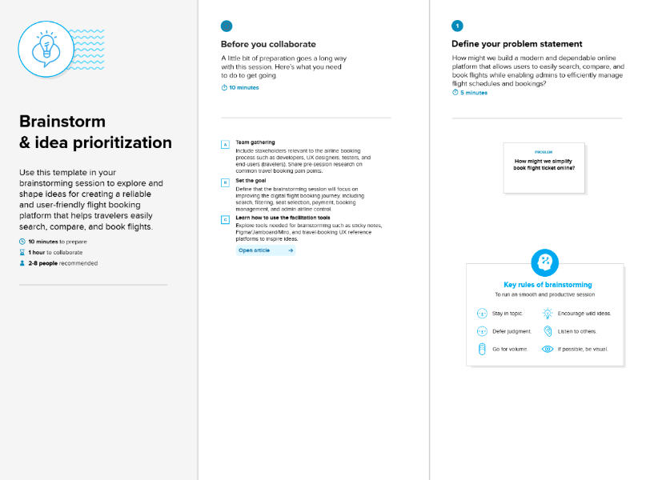

Step-2: Brainstorm, Idea Listing and Grouping

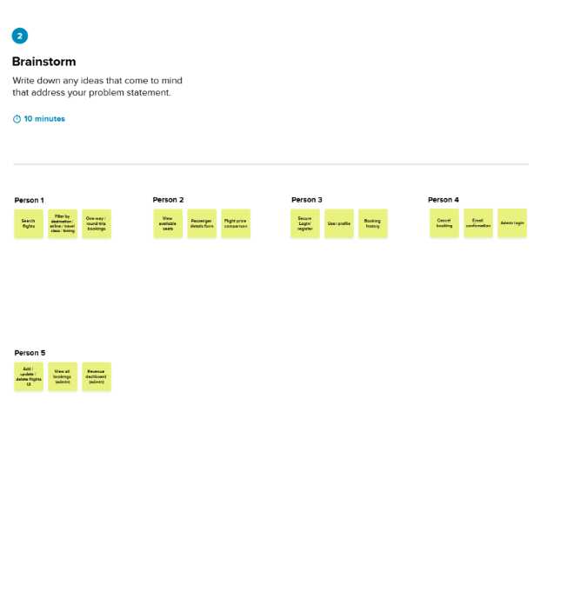

Step-3: Idea Prioritization

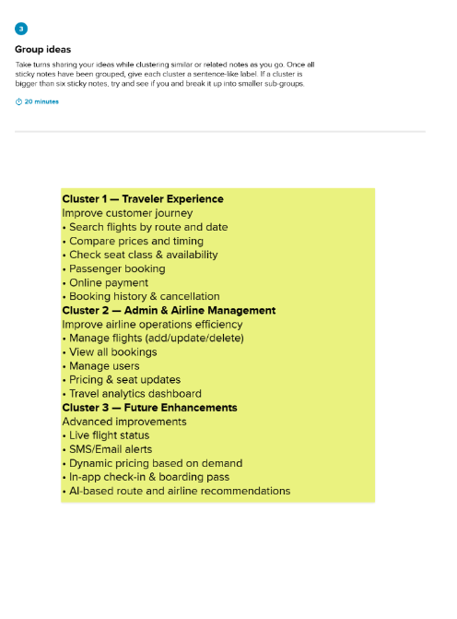

Step-3: Idea Prioritization
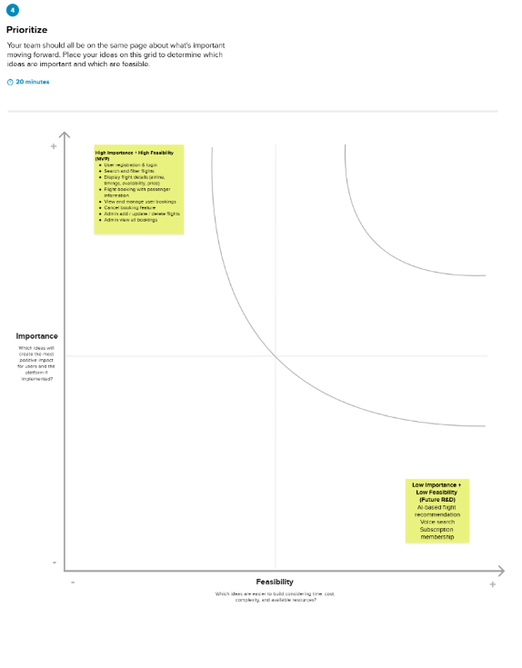

This brainstorming and prioritization process helped finalize the MVP feature list for Flight Hub, allowing us to focus first on features that are most critical and achievable, while planning future improvements for upcoming releases.

